Project 1
Project Name -

Case Study: Predicting Graduate Admissions with Linear Regression

Comprehensive Report on Predicting Admission Chances for Graduate Programs

Step 1: Exploratory Data Analysis (EDA)
Problem Definition:
We want to figure out the chances of students getting into graduate programs by looking at different academic and personal factors. Knowing which factors matter the most can help students get ready and improve their profiles.

At first we need to import all the libraries
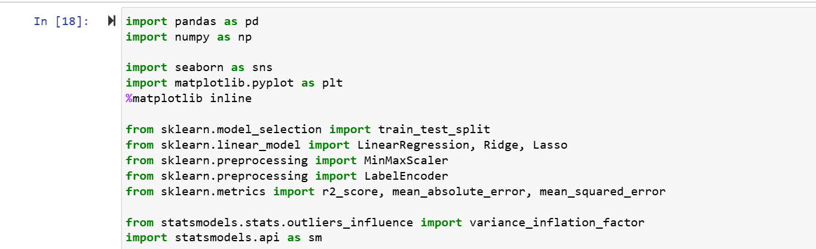

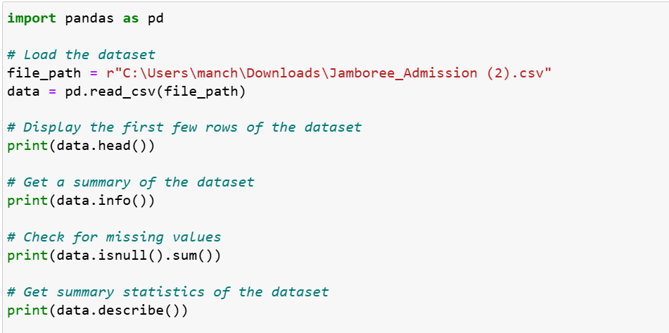

Data Structure and Characteristics:

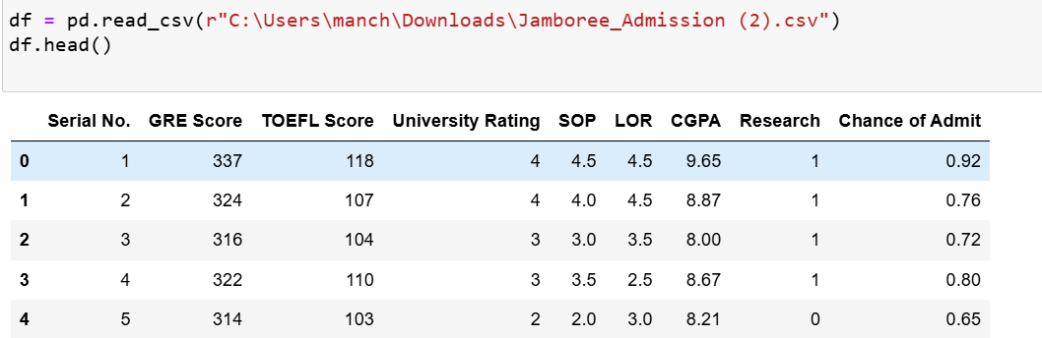

- Data Shape: 500 rows, 9 columns
- Columns:
  - Serial No.: Unique row ID
  - GRE Score: GRE scores out of 340
  - TOEFL Score: TOEFL scores out of 120
  - University Rating: University rating out of 5
  - SOP: Statement of Purpose strength out of 5
  - LOR: Letter of Recommendation strength out of 5
  - CGPA: Undergraduate GPA out of 10
  - Research: Research experience (0 or 1)
  - Chance of Admit: Probability of admission ranging from 0 to 1
- Data Types: Continuous (GRE Score, TOEFL Score, CGPA, Chance of Admit), Categorical (University Rating, SOP, LOR, Research)
- Missing Values: None
Summary Statistics:
- GRE Score: Mean = 316.47, Std = 11.30, Min = 290, Max = 340
- TOEFL Score: Mean = 107.19, Std = 6.08, Min = 92, Max = 120
- CGPA: Mean = 8.58, Std = 0.60, Min = 6.80, Max = 9.92
- Chance of Admit: Mean = 0.72, Std = 0.14, Min = 0.34, Max = 0.97
Univariate Analysis:
Generated distribution plots for continuous variables and bar plots for categorical variables to understand the data distribution.
Bivariate Analysis:
Explored relationships between important variables using scatter plots and a correlation matrix.

Step 2: Data Preprocessing
Duplicate Value Check:
- Number of duplicate rows: 0
Missing Value Treatment:
- No missing values found.
Outlier Treatment:
- Handled outliers using the Interquartile Range (IQR) method for continuous variables.
Feature Engineering:
- No new features were required.
Data Preparation:
- Removed the 'Serial No.' column for modeling.

Step 3: Model Building
Linear Regression Model:
Built a linear regression model using the Statsmodels library. Displayed model summary to interpret coefficients and significance.
Ridge and Lasso Regression:
Implemented Ridge and Lasso regression models using scikit-learn to check for improvement in model performance and model building.
Model Performance:
- Ridge Regression: Evaluated on training and test sets.
- Lasso Regression: Evaluated on training and test sets.

Step 4: Testing Assumptions of Linear Regression
Multicollinearity Check:
- Calculated Variance Inflation Factor (VIF) scores to detect multicollinearity.
Residuals Mean:
- Ensured the mean of residuals is approximately zero.
Linearity of Variables:
- Checked for patterns in the residual plot to confirm linearity.
Homoscedasticity:
- Performed Breusch-Pagan test to check for constant variance of residuals.
Normality of Residuals:
- Verified normality using QQ plots and histograms.

Step 5: Model Performance Evaluation
Metrics Calculated:
- Mean Absolute Error (MAE)
- Root Mean Squared Error (RMSE)
- R-squared (R2)
- Adjusted R-squared (Adj R2)
Train and Test Performance:
- Compared performance metrics on training and test datasets.
Performance Comments:
- Evaluated the model's performance and discussed areas for improvement.

Step 6: Actionable Insights & Recommendations
Predictor Significance:
- GRE Score, TOEFL Score, University Rating, SOP, LOR, CGPA, and Research were significant predictors.
Additional Data Sources:
- Suggested incorporating extracurricular activities, work experience, personal statements, demographic information, and interview scores for improved predictions.
Real-world Implementation:
- Integration into the application process and advisory tools for counselors.
- Periodic model updates for accuracy.
- Enhanced applicant experience, improved enrollment management, and data-driven decision-making.

Presentation Summary: Key Insights and Recommendations
1. Significant Predictors:
- GRE Score, TOEFL Score, University Rating, SOP, LOR, CGPA, and Research experience significantly influence admission chances.
2. Data Insights:
- Higher GRE, TOEFL, CGPA, and Research experience are positively correlated with admission chances.
3. Model Performance:
- Linear regression, Ridge, and Lasso models show good predictive accuracy.
- Evaluation metrics indicate the models generalize well to unseen data.
4. Recommendations:
- Incorporate additional data sources such as extracurricular activities and work experience.
- Use the model as an advisory tool for students and counselors.
- Periodically update the model with new data to maintain accuracy.
5. Implementation Benefits:
- Enhances applicant experience by providing data-backed insights.
- Helps institutions manage application volumes and make informed decisions.
- Offers a competitive edge by leveraging predictive analytics in admissions.

This report and presentation provide a comprehensive overview of the analysis, modeling, and actionable insights for predicting graduate program admission chances.

